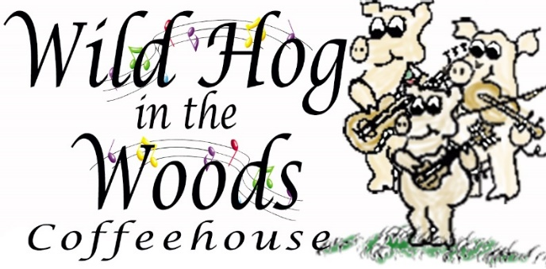

and

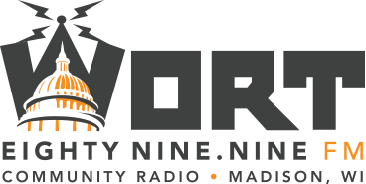
in partnership with

PRESS RELEASE
Wild Hog in the Woods and Madison Folk Music Society presents
Robert “One Man” Johnson in concert, Friday, February 21, 2020

Media Contact: Jamie Diana Poindexter  Phone: (608) 770-8092 (leave a message if not answered)  Email: jamiep@wildhoginthewoods.org | FOR IMMEDIATE RELEASE  February 6, 2020

Madison, Wisconsin - The Wild Hog in the Woods Coffeehouse, Madison Folk Music Society, and WORT 89.9 announce that Robert “One Man” Johnson will perform in concert on Friday, February 21, 2020.

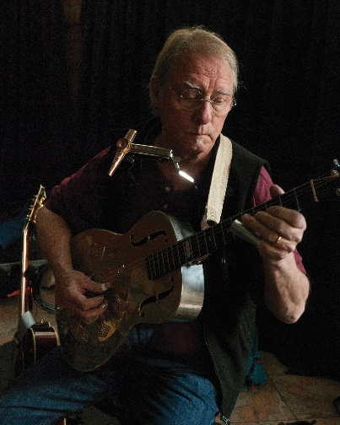
Location: Wild Hog in the Woods Coffeehouse (inside the Wil-Mar Center),
953 Jenifer Street (entrance is on Brearly Street).
Time: Doors open at 7:00 PM, concert begins 7:30 PM.
Admission: Advanced tickets $14 available online at madfolk.org
At the Door $16. MadFolk and Wild Hog members $15.
Parking: Free parking lot across Brearly Street from Wil-Mar.
Madison Metro: We are on routes 3 and 4.
Local food banks: Non-perishable donations of food will be accepted.
New: Our 50¢ cup of Steep & Brew decaf coffee is now bottomless!

PreSS KIT available
This press release and selection of high resolution photos, poster, and 60 second audio promo: wildhoginthewoods.org/PressReleases

ABOUT ROBERT “ONE MAN” JOHNSON
If you like the blues, this is a fellow you do not want to miss. Join MadFolk and Wild Hog in the Woods as we welcome Robert "One Man" Johnson a one-man band, but not a novelty act as so many such bands are presented. Johnson is a serious student of the ragtime and country blues styles, a heartfelt blues singer and an instrumentalist of great skill and exquisite taste. He finger-picks the guitar in the "Mississippi thumb" style favored by so many of the great acoustic blues artists, while playing the hi-hat cymbal with one foot and the amazing twelve-pedal twelve-string foot­piano with the other. To this he adds a harmonica in a rack, and sometimes a kazoo. Johnson's rock-steady sense of rhythm and his amazing multitasking talents blend these elements in a mix that propels you along as do the most accomplished and passionate of acoustic blues bands.

He lets his foot-piano play solo sometimes, and at other times plays leads on his harmonica or guitar. And the guitars he uses vary from solid body electrics to the Dobro to traditional acoustic six and 12 string models. He plays traditional blues pieces but also songs of his own writing, which echo perfectly the styles and themes of blues favorites from decades ago.

Robert "One Man" Johnson is originally from Wisconsin, born in Wisconsin Rapids. When he was two, his family moved to Rhinelander. Around 1954, at age 12, he received his first guitar and taught himself how to play it from "an old chord book." Initially fascinated by Elvis, Chuck Berry, and Johnny Cash, thanks to a neighbor's collection of blues 78s his interest soon shifted to the roots blues music of Arthur "Big Boy'' Crudup, Lightnin' Hopkins, Leadbelly, John Lee Hooker, Howlin' Wolf, and other early blues greats. He formed a band called The Debonaires at age 16 but continued to focus on his interest in country blues. Johnson graduated from Rhinelander High School in 1960.

Robert attended the University of Wisconsin in Eau Claire and graduated in 1967. During his Eau Claire years he ran a coffeehouse where his eventual idol, the fabulous Jesse "Lone Cat'' Fuller (about 70 years old at the time), played one lucky day in 1966. Fuller, originally from Georgia but based in California, played basically the same equipment arrangement that Robert uses today, including the foot-piano which Fuller called a "Fotdella." Since that formative day, Robert has designed and built over a dozen of these marvelous instruments.

Johnson was married in 1972 to Margery Fairchild of Iowa City. The couple went on to travel the world as educators, Robert teaching Language Arts and Margery teaching photography and other art media. While teaching in such foreign lands as Turkey, Thailand, Japan, China, and Saudi Arabia, he continued to play his blues to fascinated audiences in all those far-flung locales. According to Robert: “When we first moved to Istanbul in 1983, my thought was I was gonna have to buy Turkish instruments and try to learn how to play Turkish music, but it was exactly the opposite As soon as I got to town, people wanted to hear what I had to say and what I played. They wanted to hear the blues especially ... I had a great time, everywhere I went, finding musicians to work with, that were interested in my music."

Except for a few breaks back in the US, including one for Robert to earn his MA in Linguistics at the University of Iowa in 1990, the two spent almost thirty years tromping the globe. Somehow, Robert managed to squeeze in five appearances on A Prairie Home Companion and hundreds of gigs at Universities and concert venues around this country, including a shared show in Madison with Lou and Peter Berryman in the early 1980s and a featured appearance on the beloved Mad Toast Live with Mary Gaines and Chris Wagoner in 2013.

Robert "One-Man" Johnson has released fourteen albums over the years. His music is hard to describe properly but maybe done best by Robert himself, who says "'The spirit of the material is blues and ragtime with glints and glimmers of swing, Charleston, delta and Chicago/Memphis blues, rock and roll, and early country tunes I learned from my Uncle Johnny in Rhinelander, Wisconsin." This will be one terrific show.

Find out more about Robert “One Man” Johnson on his web site: www.housedogmusic.com

On the air at wort 89.9 fm and wortfm.org
Robert will be on the air at 11 AM the morning of the concert on Madison’s community radio station, WORT FM 89.9 FM and streamed online to the world at www.wortfm.org during the “Mud Acres” bluegrass show with Chris Powers.

About the Wild Hog in the Woods Coffeehouse
The Wild Hog in the Woods (“the Hog”) operates a 60’s style coffeehouse with live folk music and other special events, workshops, and dances in the Madison area. The Hog is a 503(c)3 membership organization, a not for profit based on cooperative principles. The Hog was started by musicians in 1978 when there were not many venues at which they could play their music. Members play an important role in the Wild Hog, volunteering their time to host the coffeehouse and other events, including promotion, booking performers, running sound, baking, newsletter and web site, and much more. We always welcome new members!

Web site: www.wildhoginthewoods.org

About the MADISON FOLK MUSIC SOCIETY
Madison Folk Music Society ("Mad Folk") is a 503(c)3 not for profit society dedicated to fostering folk and acoustic music in the greater Madison area. Revenues are derived solely from memberships and concert ticket sales, plus special gifts from members and others. Mad Folk presents six to 10 concerts each year featuring some of folk music’s finest national touring acts and often sponsors stages at local festivals and hosts outdoor concerts and sing-alongs.

Web site: www.madfolk.org

ABOUT WORT 89.9 COMMUNITY RADIO
WORT-FM is a non-commercial, listener-supported, volunteer-programmed community radio station that has operated since December 1, 1975. WORT’s mission is to provide quality programming to a broad spectrum of the community, expand the cultural experience of our listeners, facilitate community access to the airwaves, and provide a voice to those currently under-represented in the mainstream media.

Web site: www.wortfm.org

-End-

